# Reigning Weightlifting Champions with CTE

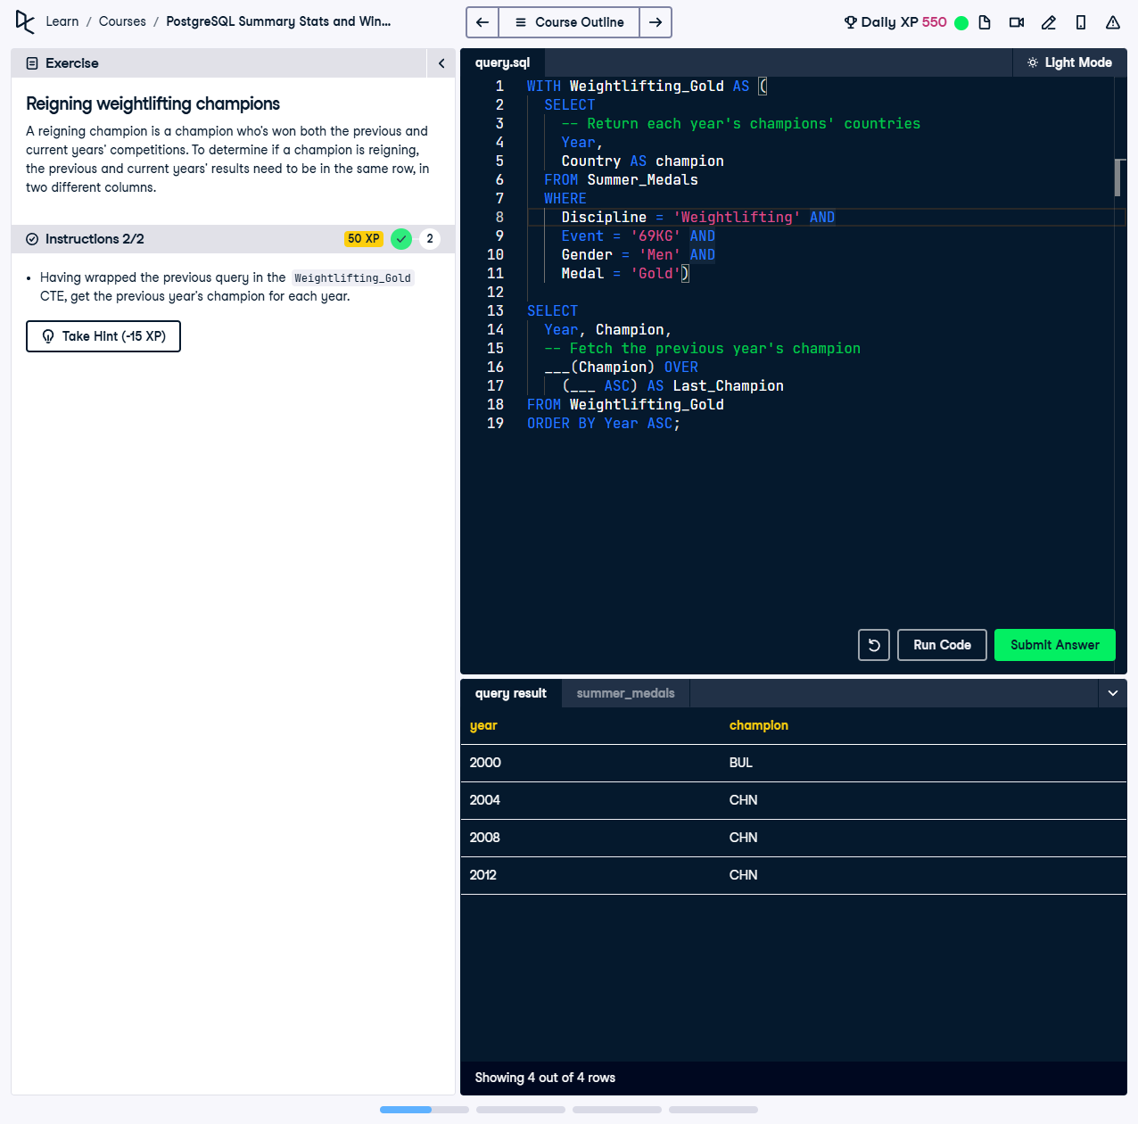

A reigning champion is a champion who’s won both the previous and current year’s competitions. To determine if a champion is reigning, the previous and current years’ results need to be in the same row, in two different columns.

This exercise involves using a Common Table Expression (CTE) to select gold medalists in the Men's 69KG weightlifting competition and then using the `LAG` function to compare the champion country of each year with the previous year's champion.

## Correct Answer

WITH Weightlifting_Gold AS (  
 SELECT   
 Year,  
 Country AS Champion  
 FROM Summer_Medals  
 WHERE   
 Discipline = 'Weightlifting' AND  
 Event = '69KG' AND  
 Gender = 'Men' AND  
 Medal = 'Gold'  
)  
SELECT  
 Year,  
 Champion,  
 LAG(Champion) OVER (ORDER BY Year ASC) AS Last_Champion  
FROM Weightlifting_Gold  
ORDER BY Year ASC;

Explanation of the query:

1. `WITH Weightlifting_Gold AS (...)`: This CTE filters the data to include only gold medalists in the Men's 69KG weightlifting event. It selects the year and country of the champion, renaming `Country` to `Champion`.

2. `LAG(Champion) OVER (ORDER BY Year ASC) AS Last_Champion`: This function retrieves the champion country from the previous year for each row, enabling the comparison of consecutive champions.

3. `ORDER BY Year ASC`: Ensures the final result is sorted in chronological order to align the years and champions correctly.